Motor Pool Vehicle Rental Trip Ticket
VEHICLE CHECK-OUT
Driver Name: Check Out Date: _________________
Vehicle Number: _____________License Plate: ___________ Odometer Out: __________________
Time Out: _______________ Fuel Out: 1/4 1/2 3/4 Full Valid Driver’s License:
Vehicle Condition:
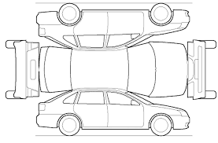
X = Dent
-- = Scratch

O = Missing

Explanation: __________________________________________
______________________________________________________

Vehicle Due Back Date:

Glove Box Documents Checked: Yes or No

I have read and agree to the terms and conditions of the University’s Vehicle Use Polity, driver safety trips, and motor pool procedures. By signing below, I verify the vehicle has been inspected with the Motor Pool staff and agree to the accuracy of the vehicle check-out conditions. My signature indicates the driver’s license presented is currently valid and not suspended, revoked, cancelled, or surrendered.
Driver Signature: _________________________________________ Date: _______________________
VEHICLE CHECK-IN Check In Date: ________________________ Time: _____________
Odometer In: __________________________
Fuel In: 1/4 1/2 3/4 Full
Glove Box Documents Checked: Yes or No
X = Dent
-- = Scratch

O = Missing

Explanation: _____________________________________________
________________________________________________________

Transportation Staff Signature: ______________________________ Date: _______________________

Driver Signature: _________________________________________ Date: _______________________
(During Open Hours Only):

