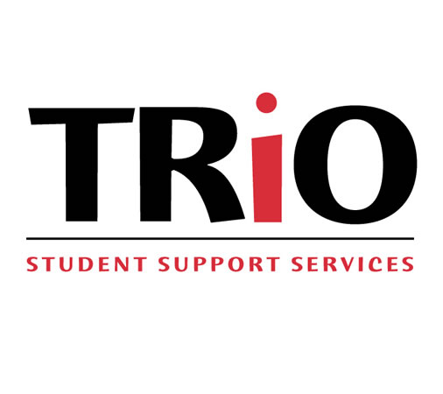
Fort Valley State University
1005 State University Drive
Fort Valley, GA 31030
Phone: (478) 822- 1074
Fax: (478) 825-7928

Student Support Services
Interest Application
2016-2017

Please complete the following interest application and return to the above address (mail or fax); your or a SSS staff member. You will be contacted in order to receive more information about the SSS Project within a few days.

Name: |  | Student ID:
Mailing Address:
City | State |  | Zip:
Cell Phone Number: |  | Home Phone Number:
Birthdate: |  | Email Address:
Citizenship:
United States Citizen Permanent Resident Alien Other ___________________________

Did your MOTHER graduate from college with a 4-year degree? NO YES

Did your FATHER graduate from college with a 4-year degree? NO YES

Are you receiving financial aid? 􀂉 Yes 􀂉 No

If Yes, are you considered an 􀂉 Independent Student OR 􀂉 Dependent Student

If No, check the reason(s): 􀂉 Have not applied 􀂉Was not eligible 􀂉 Other: ____________________

Current Classification:
Freshman Sophomore Junior Senior

When was your first semester at FVSU Month __________ Date __________ Year ______

Number of course hours completed:________ Cumulative GPA: ______________

What degree are you seeking? 􀂉 Bachelors 􀂉 Grad Student

I am interested in learning more about the SSS Project of FVSU. Please call me or send me a SSS Application Packet to the address above.

__________________________
Signature Date
Applications are accepted for review regardless of race, color, national origin, religion, gender or disability (U.S. Dept. of Education -GEPA Section 427).
Educational Talent Search Project
(ETS)

