2014
FORT VALLEY STATE UNIVERSITY

FVSU Annual Security and Safety Report
CAMPUS POLICE AND SAFETY:

The Police Department is located on the ground floor of the
Bywaters building on the main Campus.

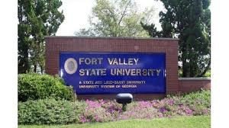

Fort Valley State University is accredited by the Commission on Colleges of the Southern Association of Colleges and Schools to award baccalaureate and master’s degrees. Contact the Commission on Colleges at 1866 Southern Lane, Decatur, Georgia 30033 -4097 or call 404-679-4500 for questions about the accreditation of Fort Valley State University.

Fort Valley State University

Primary Business Address
Your Address Line 2
Your Address Line 3
Your Address Line 4
Fort Valley State University is an affirmative action, equal opportunity institution and does not discriminate against applic ants, students or employees on the basis of race, gender, ethnicity, national origin, sexual orientation, religion, age, disability or marital or veteran status.

A Message from the President

Ivelaw Lloyd Griffith, Ph.D.

Ninth President

Fort Valley State University

Greetings,

Let me begin by expressing my sincere desire to keep FVSU as a Safe and Secure institution of higher education where all that cross the threshold of Wildcat Country will feel comfortable. As you know, security at FVSU and every place depends on the steps each of us takes to safeguard ourselves and our environment. Security is not just the responsibility of the Police and Security Officers on duty, but it is everyone’s responsibility to ensure the University is safe. To this end, it is important that all students, faculty, and staff report any criminal or dangerous situations you are aware of.

I fully expect faculty, staff and administrators to safeguard this historical University by securing the thousands of doors, windows, laboratories and buildings at all times. By taking on the aforementioned initiative, the police and security personnel can focus on keeping a less desirable element away from our Halls of Education and Living. This brochure provides a glimpse of the path FVSU travels to safeguard its stakeholders and visitors.

"We are what we repeatedly do. Excellence, then, is not an act, but a habit."-- Aristotle

"The tragedy of life doesn't lie in not reaching your goal. The tragedy lies in having no goal to reach. It isn't a calamity to die with dreams unfilled, but it is a calamity not to dream." -- Benjamin E. Mays

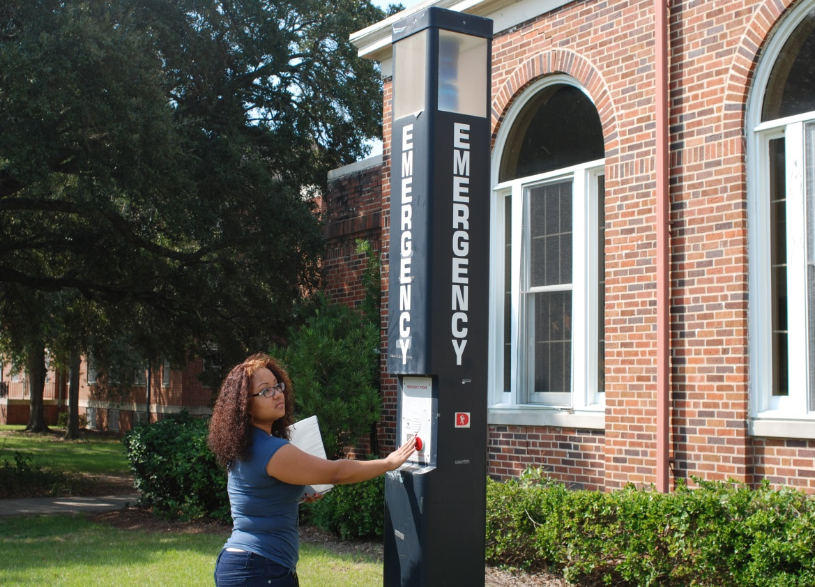
FVSU: A Safe Institution of Higher Learning

Fort Valley State University is proud to have been
a part of Fort Valley/Peach County for more than
110 years. The university’s proactive approach to safety
and crime prevention has succeeded in minimizing criminal activity on campus and promoting greater awareness and security.

The Campus Police department provides a variety of services ranging from safety escorts to crime prevention programs to investiga- tions. It is composed of more than 13 state- certified police officers, 18 full-time security guards, 25 Reserve Officers, 4 State Certified communication dispatchers and two support- ing staff members.

The department has Memorandums of Under- standing with all law enforce-
ment agencies that have con- current jurisdictional boundaries to include the Warner Robins Center related to crime. Those MOU’s are established and
kept by the Office of Legal Af- fairs.

In long established relation- ships with the other surround- ing law enforcement agencies; they provide crime related infor- mation to the Campus Police department immediately if or should crime affect our campus or University properties. .
Campus Police and Safety Contact Numbers

478-825-6211
Or
478-825-6500

Emergency Texting
911fvsu@fvsu.edu

FVSU: Department of Campus Police and Safety

MISSION

The mission of the Fort Valley State University Department of Campus Police and Safety is to ensure that the quality of campu s life is enhanced by working collectively, cooperatively and effectively with the members of the university and within the fra me- work of the U.S. Constitution. Also, our mission is to enforce the laws, preserve the peace, reduce fear and intimidation. We also strrive to provide a safe environment for all affiliates of the university. The Department of Campus Police and Safety will a bide by the rules designed and approved by the Board of Regents, who accredit state schools and universities. We will also adhere to the fundamental principle of a tradition of excellent police service and will remain in a manner that preserves and advance the democratic values of protecting the rights of all members of the university as guaranteed by the U.S. Constitution.

The FVSU Department of Campus Police and Safety is committed to maintaining the highest degree of loyalty, integrity and pro- fessionalism in all its operations. We will adhere to impeccable integrity and careful protection of the rights of those we are
sworn to serve.

STAFF

The Fort Valley State University community is guarded 24 hours 7 days a week by both armed certified police officers that en- force laws on University property and areas adjacent to University property within 500 yards. Each certified police officer has attended a law enforcement officer’s training course of a minimum of 640 hours to become certified with powers of arrest to h an- dle the reporting, investigation and assist with the prosecution of any crime. The police officer’s receive a minimum of 20 hours of recertification training each year to maintain their powers of arrest and certification. The Police force is assisted by non- certified security officers that assist the police officers with opening and closing buildings and basic security checks of buildings and facilities. All officers are training in CPR and First Aid bi-annually. In addition to Police and Security Officers, the depart- ment has certified communications officers who receive training through the Georgia POST council to handle emergency calls
for assistance from students, faculty/staff and visitors who frequent our University. The administrative secretary and recor ds clerk for the department review all Clery related reports and obtain statistical data from the departments incident reporting com- puter database, case files and daily activity log sheets, along with information from other local law enforcement agencies to in- clude the FVSU Judicial Affairs office. The statistical data found is recorded on an annual basis and logged in the U.S. Depart- ment of Education online portal each year as required by federal mandate in addition to being published into a hard copy for dis- semination to new/returning students at orientation and faculty/staff during annual faculty-staff institute. The annual crimes re- ported to FVSU and any other Institution of Higher Education can be found at the online site of http://ope.ed.gov/security/

REPORTING OF CRIMES

Fort Valley State University and the FVSU Department of Campus Police and Safety strongly encourage the accurate and prompt reporting of criminal activity on campus and off campus from property crimes to any personal or violent crime to include sexual assaults and/or general harassment. The reporting of crimes can be voluntary and/or confidential. It is to be understood that con- fidential reporting may lead to difficulty in the follow up or validation of a crime. Reporting of Crimes will be denoted in the statistical data portion of the Annual Security Report when and where required. Any crime reported whether reported voluntarily or confidentially and meets the requirements as a reportable crime per Clery rules, will be noted in the Annual Security Report. If the crime occurred of f campus, any of the below listed offices will assist with the proper reporting of the crime to the law en- forcement agency with jurisdiction over the crime. Any and everyone are encouraged to report any crimes to the following;

Campus Police (Bywaters Building) (478) 825-6211 or (478) 825-6500

Dean of Students (Student Amenities Building) (478) 825-6290 or (478) 825-6293

Director of Residential Life (Commons Club House) (478) 825-6100

Office of Judicial Affairs (Peabody Building) (478) 825-6258

FVSU: A Safe Institution of Higher Learning

Crime Prevention Tips

Here are tips from the FVSU Police on preventing some of the most common crimes:

ROBBERY
Robbery is the attempt to obtain money, personal belongings (i.e. smart phones, tablets) or property by the use of force or the threat of force. Because of the poten- tial for personal injury during a robbery, do not try to be a hero. Hand over your prop- erty quickly and quietly. If possible, ob- serve the criminal and make mental notes of the number of thieves present as well
as their appearance, clothing, voice, nick- names used, personal items, identifying marks, peculiarities and weapons. Call the police immediately upon reaching a place of safety. These precautions can help you reduce your chances of becoming a rob- bery victim:
⇒ Walk confidently with your head up, and do not let your mind wander
⇒ Pay attention to those passing you and behind you
⇒ Do not take short cuts through unlit, sparsely travelled paths, tunnels or alleys
⇒ Do not wear a lot of flashy jewelry and carry as little cash as possible
⇒ Know that weapons are not allowed on campus, but if you carry a weapon off campus, there is a possibility it could be used against you
⇒ Park in well-lighted, well-
travelled lots

THEFTs FROM VEHICLEs
You can prevent many car break-ins by thinking ahead and following these sugges- tions:

∗ Always remove the keys from your vehicle, lock all doors and roll up all win- dows, even if your stop is brief
∗ Secure or remove all valuables from view, including items such as handbags, cell phones, loose change, clothing, textbooks, book- bags, CDs, or even umbrellas
∗ Never leave personal identification documents or credit cards in your vehicle
∗ Park only in areas that are well-lit, or in attended parking lots or garages; parking in secluded or dimly lit areas makes your car an easy tar- get

Bomb Threats
A bomb threat is a federal offense that carries serious penalties. FVSU is com- mitted to identifying and prosecuting any individual calling in a bomb threat. Bomb threats are usually received by telephone. If you receive such a call, ask the follow- ing questions:
• When is the bomb going to ex- plode?
• Did you place the bomb?
• Where is the bomb located?
• What does it look like?
• What is your address?
• What kind of bomb is it?
• What is your name?
• What will cause it to explode? In addition, note the exact time of the call and write down exactly what the caller
said. Try to describe the caller’s voice and listen for any background noise. Then
notify the FVSU Police immediately by calling 478-825-6211.

UNIVERSITY HOUSING
safety
Fort Valley State University residence halls are controlled-access communities with limited access to both grounds and buildings.
A student must have card key access to open the doors and/or enter the build- ings. Student room keys are used to open individual apartments and bed- rooms. Police officers patrol in and around all residence halls continuously
to respond to the needs of the residents.
You can contact the FVSU Police by calling 478-825-6211 or by using one of the emergency phones. Security guards are on site during both evening and morning hours to assist you.

Tips for University
Housing residents
Residents should make sure to lock both the door to their apart- ment and also the door to their individual bedroom at all times when away
Before opening the door to a caller, verify the identity of the person on the other side
Never leave purses, wallets, money or valuables in plain view or in common areas
Avoid allowing someone to follow you through the security gate onto the grounds or into the building
Report all violations of unauthorized entry to the police or housing staff

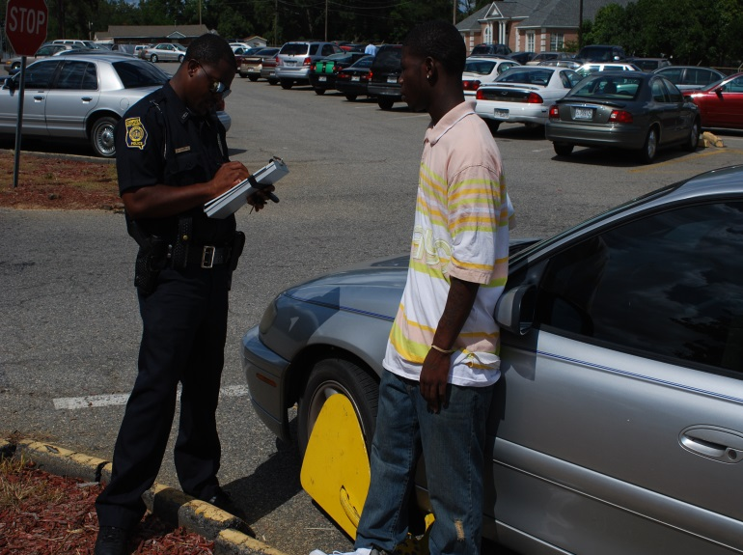

AVOIDING WORKPLACE VIOLENCE
Additional Crime Prevention Tips

Avoiding Sexual

The university is committed to creating and maintaining a working, learning and social environment that is free from violence.
Acts or threats of physical violence, including verbal abuse, harassment, terrorism, hate, prejudice, stalking, intimidation and/or coercion that involve or affect the Fort Valley State com- munity will not be tolerated. Threats or acts of violence include conduct against persons or property that are severe, offensive, and create a hostile, abusive or intimidating work environ- ment.

If you have experienced an incident that is
affecting your study or work environment and are feeling overwhelmed and stressed, we encourage you to speak to your supervisor or the dean of your college immediately. You may also seek counseling and relief by con- tacting the Counseling Center or the FVSU Police.

If someone is using abusive lan- guage or threatening you:
Try to back away from the individual
Talk calmly
Use open body language
Don’t get upset or take it personally Afterwards, you should document the threat Report the threat to management
or your dean

SEXUAL ASSAULT
The term ―sexual assault‖ refers to rape, sexual intercourse against your will or any other un- wanted physical contact of a sexual nature. Sexual assault can happen anywhere, and the assailant may be someone you know well or
not at all. It is important that you educate your- self on what constitutes a sexual offense or assault as well as ways to avoid becoming a victim.

SEX OFFENDERS
Convicted sex offenders are required by law to register their names and
addresses with the Georgia Department of Corrections. You may obtain information on individuals registered as sex offenders by visiting the Georgia Bureau of Investi- gation Sex Offender Registry website at http://gbi.georgia.gov.
Assaults
∗ Be alert to behavior that does not seem right — for example, inappropriate touch- ing or comments; someone sitting or standing too close or who blocks your way or grabs or pushes you; someone who gives you ―power stares‖ — looking through you or down at you
∗ Avoid situations in which you feel uncomfortable, such as going
into an empty house, apartment, building or parking lot
∗ Request a safety escort or travel in groups
∗ Don’t broadcast that you might be walking home alone
∗ Try to stay on main roads; avoid short-cuts through wooded areas, parking lots and alleys
∗ Walk facing traffic
∗ Walk with confidence and be aware of your surroundings
∗ Have your keys ready before you reach your car or residence-door; check both inside and outside the car before getting in
∗ Carry a whistle or a personal alarm
∗ Enroll in a self-defense class
∗ In dating situations, get to know a person really well before you are alone with that person. Be assertive and speak forcefully when someone exhibits inappropriate behavior toward you. Act immediately with some kind of negative response. Your
best defense is clear thinking.

Reporting Sexual Assault
If you are assaulted, the shock of the assault may make it difficult for you to think clearly or move quickly, but if or when you are able to flee your assailant, get to a safe place and call the local or FVSU Police as soon as possible. Also, contact a friend or a family member; it is important to seek the support and comfort of people you trust. A professionally trained coun-

selor also can help. The FVSU Police can refer you to one. FVSU Counselors and any other Pastoral styled counselors are encouraged to INFORM reported victims of reporting crimes for inclusion in the Annual Security Report.

In addition to reporting sexual assaults to the FVSU Police, such incidents should
be reported to the Dean of Students when the perpetrator is a student, or to the Of- fice of Human Resources if the perpetra- tor is a university employee.

In the case of a sexual assault, the victim’s medical and emotional needs are given first priority. The FVSU Police will:
• Assist in obtaining emergency medical assistance or counseling
• Provide transportation to a local hospital that offers services for sexual assault victims
• Initiate a criminal investigation
• Provide information about criminal procedures and prosecution

Even if you are undecided about pressing criminal charges against your assailant, all physical evidence should be preserved. You should not bathe, douche, change clothes or remove any other evidence the assailant
may have touched or dropped.

Try to remember your assailant’s description, direction of escape and the type of any vehi- cle used. The number to the Medical Center of Peach County is 478-654-2000.

University Title IX
Notice of Nondiscrimination

Fort Valley State University does not discrimi
-nate on the basis of sex in its education programs and activities and prohibits such discrimination by students, faculty and staff. Nondiscrimination on the basis of sex is mandated by Title IX of the Education Amendments of 1972 (20 U.S.C. §§ 1681 et seq.), and the corresponding implemen- tation regulations (34 C.F.R. Part 106).

Title IX prohibits sex discrimination. Sex discrimination constitutes sexual misconduct and includes both sexual harassment and sexual violence.

Did you know sexual misconduct is any kind of unwanted sexual contact including sexu- al contact with someone who is unable to give legal consent due to intoxication or being under- age? W ould it surprise you to learn that hooking up with your girl or boyfriend while drunk, post- ing/ sharing revealing photos of someone with- out their consent, or showing/sending revealing photos to someone who doesn’t want to see them can all constitute sexual misconduct?

Reporting sex discrimination/misconduct: Sex discrimination including sexual miscon- duct should be immediately reported to a FVSU Title IX Coordinator. Sexual miscon- duct by university students, faculty or staff should be immediately reported to one of the university’s designated Title IX Coordinators as set forth below.

Title IX Coordinators

TITLE IX COORDINATOR –
Special Assistant to the President for Compli- ance/Director Strategic Initiatives Responsibilities:
Responding to reports of sexual
misconduct by faculty and staff.
Overseeing Title IX complaints and identifying/addressing any pat- terns or systemic problems that arise during the review of such complaints, in consultation with the Office of Legal Affairs.
Conducting Title IX training. Contact Information:
Special Assistant to the President for Compliance/EEOC
1005 State Univ. Drive/Troup
Bldg Suite 322
Fort Valley, GA 31030
Tel: 478-825-6333
Email: eadyd@fvsu.edu

DEPUTY TITLE IX COORDINATOR/ Human Resources – Chief Human Resources Officer
Responsibilities:
Responding to reports of sexual misconduct by students.
Contact Information:
Human Resources Office
Troup Building
Tel: 478-825-6301
Email: addisont@fvsu.edu

DEPUTY TITLE IX COORDINATOR/ ATH- LETIC – Assistant Athletic Director/SW A/ Compliance Office
Responsibilities:
Responsible for the Title IX compli- ance of the FVSU athletic pro- gram (i.e. gender equity in the university athletics).
Contact Information:
HPE Complex
Tel: 478-825-6888
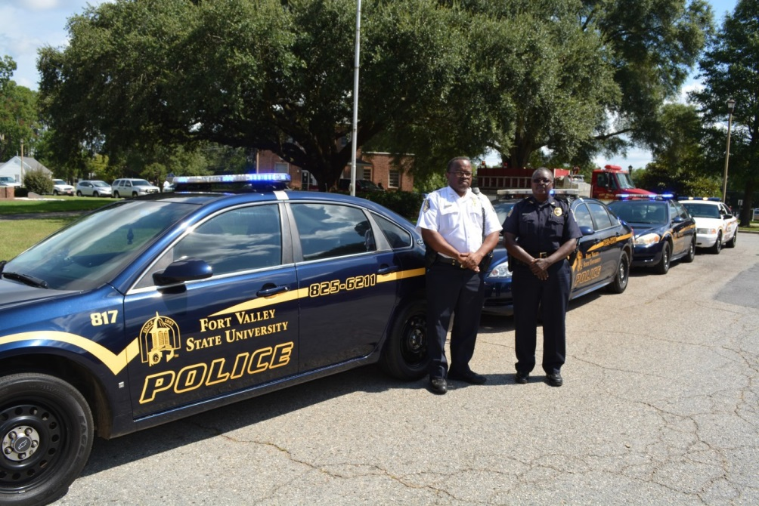
Email: williamsl@fvsu.edu

University policy:

Student Sexual Misconduct is governed by the FVSU Student Code of Conduct Sexual Misconduct Policy available at: www.fvsu.edu/.
Employee Sexual Misconduct is governed by the Fort Valley State University Employee Handbook

Inquiries:

Inquiries about Title IX may be addressed to the Title IX Coordinators listed above or the Office of Legal Affairs.

The Sexual Assault
Bill of Rights
Victims of campus-related sexual assaults shall be accorded the following rights by all FVSU campus offic- ers, administrators and employees:

The right to have any and all sexual assaults against them treated with seriousness; the right, as victims, to be treated with dignity; and the right for campus organizations that assist such victims to be accorded recognition.

The right to have sexual assaults committed against them investigated and adjudicated by the duly consti- tuted criminal and civil authorities of the governmental entity in which the crimes occurred; and the right to the full and prompt cooperation and assistance of campus personnel in notifying the proper authorities. The foregoing shall be in addition to any campus disciplinary proceedings.

The right to be free from any kind of pressure from campus personnel that victims (i) not report crimes committed against them to civil and criminal authorities or to campus law enforcement and discipli- nary officials; or (ii) report crimes as lesser offenses than the victims perceive them to be.

The right to be free from any kind of suggestion that campus sexual assault victims not report, or un-
der-report, crimes because (i) victims are somehow ―responsible‖ for the commission of crimes against them; (ii) victims were contributorily negligent or assumed the risk of being assaulted; or (iii) by reporting crimes that would incur unwanted personal publicity.

The right to legal assistance, or ability to have others present, in any campus disciplinary proceeding that the institution permits to the accused; and the right to be notified of the outcome of such proceeding. The right to full and prompt cooperation from campus personnel in obtaining, securing and maintaining evi- dence (including a medical examination) as may be necessary to the proof of criminal sexual assault in subsequent legal proceedings.

The right to be made aware of, and assisted in exercising, any options, as provided by state and federal laws or regulations, with regard to mandatory testing of sexual assault suspects for communicable diseases and with regard to notification to victims of the results of such testing.

The right to counseling from any mental health services previously established by the institution, or by other victim-service entities, or by victims themselves.

After campus sexual assaults have been reported, the victims of such crimes shall have the right to require that campus personnel take the necessary steps or actions reasonably feasible to prevent any unnecessary or unwanted contact or proximity with alleged assailants, including immediate relocation of the victim to safe and secure alternative housing and transfer of classes if requested by the victims.

In addition to the above rights, students, whether sexual assault victims or not, have the right to habitability in campus accommodations for which the college receives any compensation, direct or indirect. Habitability
shall mean an environment free from sexual or physical intimidation or any other continuing disruptive behav-
ior that is of such a serious nature as would prevent a reasonable person from attaining their educational goals. Substantiated violations of the above-listed habitability provisions shall be corrected by campus per- sonnel by relocations, if reasonably possible, of the complainant to an acceptable, safe and secure alternative location as soon as practical, unless the conditions of nonhabitability demonstrate the necessity of immediate action by campus personnel.

These rights are established and are implemented in conjunction with the Fort Valley State University Har- assment Policy and Procedures, which include informal procedures for counseling and mediation and for- mal complaint procedures.

Missing Student REPORTS
Policies and procedures for proper, timely notification

This policy contains the official notification procedures for Fort Valley State University concerning missing stu- dents who reside in on-campus housing, in accordance with the requirements of the Higher Education Oppor- tunity Act of 2008 (HEOA). The purpose of this policy is to promote the safety and welfare of members of the college community through compliance with HEOA requirements. This policy should be adhered to by all col- lege faculty, staff, and students.

In the event that a member of the college community has reason to believe that a student who resides in on- campus housing is missing, he or she shall immediately notify the Director of Housing or his/her designee as soon as possible. After which, a report must be made by the Director of Housing to the Fort Valley State Univer- sity Department of Public Safety (CAMPUS POLICE & SAFETY) immediately. Following notice to the University Police Department, the Director of Housing, or his/her designee, is responsible for immediately notifying the Dean of Students, or his/her designee, of the report. Fort Valley State University CAMPUS POLICE & SAFETY will generate a missing person report and initiate an investigation. In addition, Fort Valley State University CAMPUS POLICE & SAFETY will report the missing person to Residence Life if such information has not al- ready been conveyed.

During the course of the investigation, Fort Valley State University CAMPUS POLICE & SAFETY will determine if the student has been missing more than 24 hours. In such event Fort Valley State University CAMPUS POLICE
& SAFETY will notify all surrounding law enforcement agencies and the student’s emergency contact no later
than 24 hours after the student is determined to be missing. If the missing student is under the age of 18 and is not an emancipated individual, Fort Valley State University CAMPUS POLICE & SAFETY will notify the student’s parent or legal guardian immediately after they determine that the student has been missing for more than 24 hours.

In addition to registering emergency contacts, students residing in on-campus housing have the option to iden- tify confidentially an individual to be contacted by Fort Valley State University in the event the student is deter- mined to be missing for more than 24 hours. If a student has identified such an individual, Fort Valley State Uni- versity will notify that person no later than 24 hours after the student is determined to be missing. Students
who wish to identify a confidential contact can do so by completing the appropriate paperwork during check-in
procedures. A Student’s contact information will be registered confidentially, that this information will be ac- cessible only to duly authorized University officials and it may not be disclosed, except to law enforcement in furtherance of a missing persons investigation.

This policy is effective from the date of issuance and will be made available to all members of the campus com- munity. Its availability will be through postings on the college website, emergency response plan manual, Resi- dence Life handouts/publications and statistical information brochures issued annually by Fort Valley State Uni-

CRIMES STATS 2011 TO 2013
OFFENSE | ON CAMPUS |  |  | RESIDENTIAL FACILITIES |  |  | NON-CAMPUS |  |  | PUBLIC PROPERTY
 | YEAR  2011 | YEAR  2012 | YEAR  2013 | YEAR  2011 | YEAR  2012 | YEAR  2013 | YEAR  2011 | YEAR  2012 | YEAR  2013 | YEAR  2011 | YEAR  2012 | YEAR  2013 | YEAR  2011 | YEAR  2012 | YEAR  2013
Murder/Non-Negligent Manslaughter | 0 | 0 | 0 | 0 | 0 | 0 | 0 | 0 | 0 | 0 | 0 | 0 | 0 | 0 | 0
Negligent Manslaughter | 0 | 0 | 0 | 0 | 0 | 0 | 0 | 0 | 0 | 0 | 0 | 0 | 0 | 0 | 0
Sex Offense— Rape | 0 | 1 | 0 | 0 | 1 | 0 | 0 | 0 | 0 | 0 | 0 | 0 | 0 | 1 | 0
Sex Offense– Fondling | 0 | 0 | 0 | 0 | 0 | 0 | 0 | 0 | 0 | 0 | 0 | 0 | 0 | 0 | 0
Sex Offense—Incest | 0 | 0 | 0 | 6 | 0 | 0 | 0 | 0 | 0 | 0 | 0 | 0 | 0 | 0 | 0
Sex Offense— Statutory Rape | 0 | 0 | 0 | 0 | 0 | 0 | 0 | 0 | 0 | 0 | 0 | 0 | 0 | 0 | 0
Robbery | 0 | 0 | 0 | 0 | 0 | 0 | 0 | 0 | 0 | 0 | 0 | 0 | 0 | 0 | 0
Aggravated Assault | 0 | 0 | 0 | 0 | 0 | 0 | 0 | 0 | 0 | 0 | 0 | 0 | 0 | 0 | 0
Burglary | 6 | 1 | 0 | 6 | 1 | 2 | 0 | 0 | 0 | 0 | 0 | 0 | 12 | 2 | 2
Motor Vehicle Theft | 0 | 1 | 0 | 0 | 0 | 0 | 0 | 0 | 0 | 0 | 0 | 0 | 0 | 1 | 0
Arson | 0 | 0 | 0 | 0 | 0 | 0 | 0 | 0 | 0 | 0 | 0 | 0 | 0 | 0 | 0
 | 0 | 0 | 0 | 0 | 0 | 0 | 0 | 0 | 0 | 0 | 0 | 0 | 0 | 0 | 0
VAWA AMENDMENT OFFENSES | 0 | 0 | 0 | 0 | 0 | 0 | 0 | 0 | 0 | 0 | 0 | 0 | 0 | 0 | 0
 | 0 | 0 | 0 | 0 | 0 | 0 | 0 | 0 | 0 | 0 | 0 | 0 | 0 | 0 | 0
Domestic Violence | 0 | 0 | 0 | 0 | 0 | 0 | 0 | 0 | 0 | 0 | 0 | 0 | 0 | 0 | 0
Stalking | 0 | 0 | 0 | 0 | 0 | 0 | 0 | 0 | 0 | 0 | 0 | 0 | 0 | 0 | 0
Dating Violence | 0 | 0 | 0 | 0 | 0 | 0 | 0 | 0 | 0 | 0 | 0 | 0 | 0 | 0 | 0

TOTAL

TOTAL

Note: Crimes reported in the residential facilities are also included in the on campus category. Fort Valley State University began tracking crimes between the campus and housing separately on the annual report in 2013. Hate crime statistics include those from manslaughter, forcible and non-forcible sex offenses, robbery, aggravated assault, burglary, motor vehicle theft, arson, larceny, vandalism, simple assaults, intimidation and damage/vandalism of property. *Non-forcible sex offenses based on the Clery Act for reporting purposes should only include incest and statutory rape.
OFFENSE | ON CAMPUS |  |  | RESIDENTIAL FACILITIES |  |  | NON-CAMPUS |  |  | PUBLIC PROPERTY
 | YEAR  2011 | YEAR  2012 | YEAR  2013 | YEAR  2011 | YEAR  2012 | YEAR  2013 | YEAR  2011 | YEAR  2012 | YEAR  2013 | YEAR  2011 | YEAR  2012 | YEAR  2013 | YEAR  2011 | YEAR  2012 | YEAR  2013
Other Offenses
Liquor Law Violations | 2 | 2 | 1 | 2 | 1 | 1 | 0 | 0 | 0 | 0 | 0 | 0 | 40 | 3 | 2
Drug VAbuse Violations | 4 | 9 | 5 | 4 | 3 | 3 | 0 | 0 | 0 | 0 | 0 | 0 | 8 | 12 | 8
Weapons, carrying, etc. | 4 | 2 | 1 | 4 | 0 | 0 | 0 | 0 | 0 | 0 | 0 | 0 | 8 | 2 | 1

It was discovered that after a professional review of the 2013 FVSU—ASR, the Warner Robins Center was not a completely separate branch complete with its own separate set of administrators, so therefore any Clery reportable crimes will be contained with the overall statistical data for the University referenced above and will not be separated.

SEE IT! or HEAR IT!

REPORT IT! (478) 825-6500 or
TEXT IT! 911fvsu@fvsu.edu

Property Safety Tips

The most frequently reported crimes are those involving theft of personal or institutional property. The follow- ing are some of the most frequent targets of theft reported to the FVSU POLICE and some security tips to help you protect your property.

Vehicles

• Always lock your vehicle, and do not leave the keys inside it.

• Remove all valuable items from your vehicle, including GPS de- vices and their mounts, clothing, electronics, purses, wallets, and change. Store valuables out of sight in your trunk if they must remain in your vehicle.

• Close all windows, and make sure the trunk and all doors are secured.

• Do not leave your vehicle regis- tration and important identifica- tion papers inside your vehicle.

• Keep your vehicle’s tag number, vehicle identification number (VIN), and a complete descrip- tion of your vehicle in your wallet or a safe place at your resi- dence.

• Remove electronic devices, their mounts, and chargers from your vehicle.
• Park in well-lit, busy areas, and do not leave your vehicle in unat- tended lots for long time frames.

• Install a security device, such as a steering column lock or a cut- off switch, that interrupts fuel or ignition systems.

• Secure your vehicle’s license plate with tamper-proof bolts.

Bicycles

• Park your bicycle in areas with a high volume of pedestrian traffic.

• Lock your bicycle with a U-
shaped lock.

• Engrave your bicycle with an owner identification number.

• Register your bicycle for free with the FVSU POLICE. A record will be made of the make, model, manufacturer’s serial number,
and the owner identification num- ber.

Computers and
Other Office Equipment

• Lock your room or office every time you leave.

• Keep records of your equipment including a description of the equipment along with the make, model, and manufacturer’s serial number.
• Engrave or apply an owner or de- partmental identification marking where possible.

• Secure computers with cable locks or other security devices.

• Install burglar alarms capable of being monitored by the FVSU PO- LICE in computer labs, offices, or storage areas that contain large quantities of valuable office or re- search equipment.

• Consider purchasing and installing a tracking device on your laptop,.

• Remember, free security surveys are offered by the FVSU POLICE for campus buildings and on- campus residents.

Textbooks and
Thefts from Dorm Rooms

• Write your name or owner identifi- cation number on several pages inside your books.

• Never leave your book bag or books unattended at the library, dining halls, classrooms, lounge areas, or Campus Student Centers.

• While dorm rooms are safe places to store clothes, televisions and other items, they can be broken into. Always store valuables in lock boxes inside your room. Know
who is in your room at all times and secure it each time you leave.

Timely Warning Notices

Purpose: The purpose of this policy is to outline procedures that Fort Valley State University will use to issue Timely Warnings in compliance with the Clery Act.

Fort Valley State University will issue a Timely Warning Notices in the event that it receives notice of an alleged Clery Crime (defined below) occurring on campus, on public property within or immediately adjacent to the campus, or in or on non-campus buildings or property controlled by Fort Valley State University, where the Fort Valley State University determines, in its judgment, that the allegations pre- sent a serious or continuing threat to the Fort Valley State University community. For purposes of this policy, “timely” means as soon as reasonably practicable, generally not more than 48 hours after an incident has been reported to the Department of Campus Police and Safety. Authorities identified by Fort Valley State University, or local police agencies that have concurrent jurisdiction have reported the information to the Fort Valley State University. The Chief of Police/Director of Campus Police and Safe-
ty, or, in his absence or unavailability, his designee, is responsible for determining whether to issue a Timely Warning Notice. If the Director or
designee is not available, the determination will be made by a member of the Fort Valley State University’s emergency respons e and planning committee.

Whether to issue a Timely Warning Notice is determined on a case-by-case basis for Clery Act crimes: arson, homicide, burglary, robbery, forci- ble and non-forcible sex offenses, aggravated assault, motor vehicle theft, domestic violence, dating violence, stalking and Hate Crimes, as de- fined by the Clery Act.1 Notices also may be distributed for other crimes as determined necessary by the Director of Campus Police and Safety or the designee in his/her absence.

In determining whether to issue a Timely Warning, Fort Valley State University will consider any factors reflecting on whether the alleged crime represents a serious or continuing threat to the Fort Valley State University community, including, but not limited to, (a) t he nature of the inci- dent; (b) when and where the incident occurred; (c) when it was reported; (d) the continuing danger to the campus community; and (f) the amount of information known by the Department of Campus Police and Safety. If there is insufficient information available to determine wheth- er the incident represents a continuing threat to the Fort Valley State University community, the University will issue a Timely Warning unless, based on the information available, it appears unlikely that there is an ongoing threat to the Community, and will note in the content of the Timely Warning that, based on the information available, the University does not have full information to evaluate the nature of the ongoing threat.

A hate crime is a criminal offense of murder and non-negligent murder, forcible sex offenses, non-forcible sex offenses, robbery, aggravated assault, burglary, motor vehicle theft, arson, larceny-theft, simple assault, intimidation, destruction/damage/vandalism of property, domestic violence, dating violence, or stalking incidents, where the criminal offense was committed against a person or property which is motivated, in whole or in part, by the offender’s bias. Bias is a preformed negative opinion or attitude toward a group of persons based on their race, gender, gender identity, religion, disability, sexual orientation or ethnicity/national origin.

The Director of Campus Police and Safety will make efforts to consult with the Director of Marketing and Communications or a designee, if s/he is available, to develop the content of the Timely Warning Notice. The Fort Valley State University’s Title IX Coordinator may also be consulted in appropriate situations.

The Timely Warning Notice will typically include, to the extent known, the date, time and nature of the offense, a brief overview of its particular circumstances, a physical description of the actor(s), law enforcement’s immediate actions, a request and method for witnesses to contact law enforcement, and where applicable and appropriate, cautionary advice that would promote safety. In developing the content of the Timely Warning Notice, the University will take all reasonable efforts not to compromise ongoing law enforcement efforts.

Fort Valley State University distributes Timely Warning Notices in various ways. Once the Fort Valley State University determines that an alert will be issued, the Department of Public Safety e-mails the announcement and posts it on its website (www2.fvsu.edu), and posts alerts on bulletin boards throughout campus when feasible. The Fort Valley State University will also send email, text and voicemail messages disseminating the notice to those who register their cell phone numbers in Banner or ADP.

Anyone with information about a serious crime(s) or incident(s) should report the cir- cumstances to the Department of Campus Police and Safety by phone at (478) 825-
6211) or in person at the Bywaters Building. If a report is made to other Fort Valley State University administrators, those administrators will immediately notify the De- partment of Campus Police and Safety.

Annual Student Housing Fire Safety Report in Accordance with the Higher Education Opportunity Act (PL 110-315)

Fort Valley State University’s fire safety policy and rules are intended to prevent fires and fire-related injuries and/or deaths from occurring or affecting the FVSU community and facilities. All FVSU buildings are inspected annually, and residential rooms are inspected periodically, at ran- dom times during the year, to ensure compliance with state fire codes. Because of the seriousness of the consequences that could result from failure to comply with codes and FVSU ’s fire safety rules, FVSU takes disciplinary action on the first offense. This may include the imposition of a fine by the Housing Department. The Institution also has the right to require students who violate safety rules to vacate the ir accommodations — without financial credit for the remainder of the semester. The FVSU Department of Campus Police and Safety maintains reports of all Fires and/ or Fire Drills and Prevention efforts for the University. The Department’s Admin Secretary and Records Clerks annually review the same records computer database as well as actual reports as crime reporting in order to record that statistical data in compliance with Clery rules and within the ASR. Because Campus Police investigates fires as well as criminal activity all fire calls are documented on the same daily activity log as crime.

Fire Safety Standards

Prohibited Behaviors in FVSU Residential Facilities

• Misusing or tampering with fire-safety equipment. This includes, but is not limited to, fire extinguishers, hoses, horns, bells, conduit sections, alarm-pull trigger devices, fire sprinklers, central-relay control bases, and glass covers for fire extinguishers, as well as pulling false alarms.
• Obstructing hallways, sidewalks, or stairwells that might impede evacuation from a building during an emergency.
• Propping open interior fire doors in common areas, stairwells, and hallways. Those are in place for added fire protection to slow the spread of fire.
• Storing bicycles in stairwells or any other location that might impede evacuation from a building during an emergency.
• Possessing chemicals or substances that are potentially dangerous or highly flammable. This includes, but is not limited, to gasoline, pro- pane, lighter fluid, torches, etc.
• Leaving food cooking unattended.
• Failing to vacate the building when the fire alarm system is activated.

Open Flames

• Candles, incense burners, and other open flame devices are strictly prohibited.
• Using items that are potentially dangerous and/or flammable, including fireworks, hazardous materials, etc., is also prohibit ed.

Smoking

• Smoking is prohibited in all residence hall areas (rooms, apartments, suites, common areas, lobbies, lounges, stairwells, elevators, activity/
recreation rooms, bathrooms, etc.). Those who choose to smoke must do so at least 25 feet from any residence hall.

Fire Safety Inspections

The FVSU Fire Safety Office located within the Department of Campus Police and Safety conducts yearly fire inspections in the residence halls within the first month of each semester, checking rooms for fire or unusual safety hazards and to ensure compliance with the following:

• No halogen-touchier lights. The intense heat generated by these bulbs creates a fire hazard and a potential source of burns. These bulbs start fires if they come in contact with curtains, clothes, paper, and other flammables. In addition, the lamps are unstable and can be easily tipped over.
• No overloaded electrical circuits. There can be only one major appliance (such as a refrigerator, TV, computer, microwave, etc.) per recepta- cle plug.
• No hanging of items from overhead lights, sprinkler heads, or pipes. No attachments to the ceiling.
• Immediate and proper disposal of appliances with old or damaged cords.
• Use of electrical appliances that meet the Underwriter’s Laboratory (UL) or Electrical Testing Labs (ETL) safety standards.
• No removal of grounding pins from three-pronged electrical cords.
• No unattended operating of coffee makers and other appliances with exposed heating elements. They must be unplugged after each use and stored appropriately.
• No running of cords under carpet. Avoid stapling or tacking electrical wires to fixtures (on walls, over doorways, on ceilings, etc.).
• No open-element hot plates.

Regular Mandatory Supervised Fire Drills

Fort Valley State University’s Residential Life Department, in conjunction with the FVSU Fire Safety Office and the FVSU Pol ice Department (FVSUPD), conducts emergency evacuation drills each year. These drills are conducted within 10 days of the beginning of classes each semester. During this past year there were a total of 62 fire drills conducted University wide. During fire evacuation drills, each fire alarm system in each on
-campus student housing facility is activated. Once the alarm has been activated, students and visitors must exit immediately and gather at the designated evacuation safe refuge location. A sweep of all floors and a head count is conducted by a Residential Life representative and FVSUPD officer. Only when the alarm is silenced and the FVSUPD or local authority gives the “all clear,” will reentry into the build ing be permitted. Stu- dents who do not vacate the building when a fire alarm is activated may be subject to judicial action. Residential Life RLC’s and RA’s receive classroom and hand-on training in the following areas: Fire extinguisher use, Evacuation and emergency preparedness, Kitchen fire safety, Life safety systems, FVSU Fire Safety Rules and Fire Inspection program

Note: For these drills only, the fire alarm system is reset by the Fort Valley State University Fire Safety Office.

Fire Protection Systems

Fire Alarm Systems/Initiation and Pull Stations

Fire alarm pull stations are generally located at exit doors, stairways, and at elevators in FVSU residential facilities. Once the
alarm is activated, the Fort Valley State University Police Communications Center automatically receives the signal and responds by contacting
FVSU Police and the Fort Valley Fire Department.

Smoke Detection

Smoke detectors are located throughout each floor of every residential facility on campus. If smoke is detected, the fire alarm system will auto- matically send a signal to the central station monitor.

Sprinkler System

The rise of temperature associated with fire in an area will activate the sprinkler system and send an alarm signal to the central station monitor. Currently, 90 percent of FVSU housing beds are covered by sprinkler protection. Future renovation project plans will
accomplish 100 percent sprinkler coverage. Future renovations or demolition are projected for Josie Hall which was built in the 1970’s which will increase the percentage to 100.

Sprinkler heads must not be tampered with or used as a means to hang personal items. This could cause malfunctioning of the system or sub- stantial water damage if one of the heads accidentally discharges. These sprinklers disperse 25 to 40 gallons of water per minute. Fort Valley State University is not responsible for any loss a student may incur as a result of tampering with sprinkler heads. A resident who knowingly or accidentally causes a sprinkler to activate may be charged for the repairs/cleanup and may be subject to judicial proceedings.

Note: It is against federal and state laws to tamper with or interfere with life and safety equipment. Destroying fire exit signs, fire alarm boxes, and other safety items could lead to disciplinary action, and the resident may be charged for the repairs/cleanup.

Evacuation Plans

General Procedures

If smoke or a fire is discovered, the fire alarm must be activated immediately. Exit through the nearest door or stairway and proceed to the desig- nated safe refuge area. If the nearest exit or exit stairwell is obstructed by smoke, fire, or other hazards, proceed to an alternate exit or exit stair- well. Do not use elevators. Once assembled outside at the Emergency Evacuation Assembly Point, Residential Life RLC’s and RAs will account for all occupants and communicate with first responders if anyone is not accounted for and provide other information vital to safety and rescue. Building occupants shall not reenter the building until the Authority Having Jurisdiction gives the “all clear.”

Reporting Fires

To report a fire, students, employees, or visitors should call 911 or the Fort Valley State University Police Communications Center at (478) 825-
6500 from any campus landline. Alternatively, callers can dial (478) 825-6304 from a cellphone. Either option will ensure the quickest response and will also ensure that other Fort Valley State University personnel, as appropriate, are notified.

ON CAMPUS RESIDENTIAL FACILITIES NON-CAMPUS PUBLIC PROPERTY TOTAL
Fire Safety YEAR YEAR YEAR YEAR YEAR YEAR YEAR YEAR YEAR YEAR YEAR YEAR YEAR YEAR

YEA R

2011 2012 2013 2011 2012 2013 2011 2012 2013 2011 2012 2013 2011 2012 2013

Fires 5 3 4 0 0 0 0 0 0 0 0 0 5 3 4
Fire Drills 68 74 62 0 0 0 0 0 0 0 0 0 68 74 62
Alarm Activations 43 27 62 0 0 0 0 0 0 0 0 0 45 27 62

For More Information In Case of Emergency

Campus Police…………478.825.6211 Fire-Medical-Police…………...911

Counseling Center……..478.822.1035 FVSU Police Dept……………...478.825.6500

Dean of Students……….478.825.6290 Counseling Center……………..478.822.1035

Residential Life………...478.825.6100 Medical Center Peach County...478.654.2000

Health Services………...478.825.6278 Warner Robins Police………….478.929.1170

Human Resources……...478.825.6301 Peach Co. Sheriff Office………..478.825.8636

Title IX Office……….…478.825.6333 FVSU Emergency Texting...911fvsu@fvsu.edu

Additional Higher Education Crime Statistical Data can be viewed via the following website: http://www.ope.ed.gov/security/

